DATA STRUCTURE

A data structure is a way of storing data in a computer so that it can be used efficiently and it will allow the most efficient algorithm to be used. ... A well-designed data structure allows a variety of critical operations to be performed, using as few resources, both execution time and memory space, as possible.

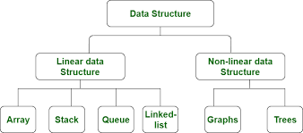
* Classsification of data structure

Array
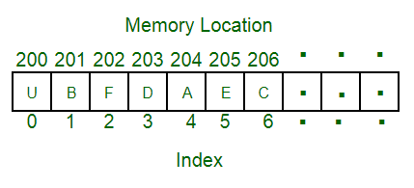
An array is a collection of items stored at contiguous memory locations. The idea is to store multiple items of the same type together. This makes it easier to calculate the position of each element by simply adding an offset to a base value, i.e., the memory location of the first element of the array (generally denoted by the name of the array).

Linked list

A linked list is a linear data structure, in which the elements are not stored at contiguous memory locations. The elements in a linked list are linked using pointers as shown in the below image:In simple words, a linked list consists of nodes where each node contains a data field and a reference(link) to the next node in the list.

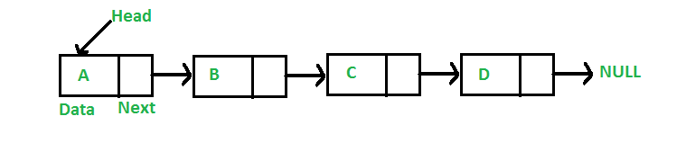
Stack

Stack is a linear data structure which follows a particular order in which the operations are performed. The order may be LIFO(Last In First Out) or FILO(First In Last Out)
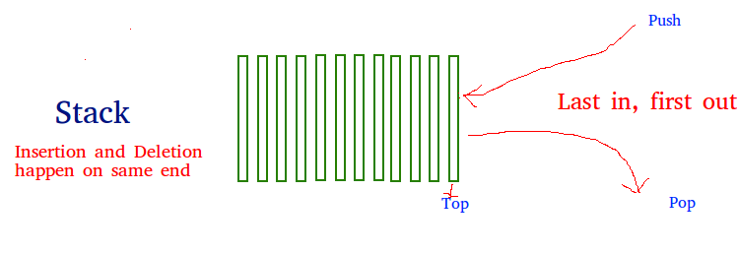
Queue

A Queue is a linear structure which follows a particular order in which the operations are performed. The order is First In First Out (FIFO). A good example of a queue is any queue of consumers for a resource where the consumer that came first is served first. The difference between stack and queues is in removing. In a stack we remove the item the most recently added; in a queue, we remove the item the least recently added

